2.2 **Add variables**

|  |  |
| --- | --- |
| Date | **25 June 2025** |
| Team ID | **LTVIP2025TMID29028** |
| Project Name | **Laptop Request Catalog Item** |
| Maximum Marks | **5 Marks** |

**Step1:**

* After saving the catalog item form scroll down and click on variable(related list)
* Click on new and enter the details as below

1. Variable 1:Laptop Model

             Type: Single line text

             Name: laptop_model

             Order:100

* Click on submit
* Again click on new and add Remaining variables in the above process

  2. Variable 2:Justification

             Type: Multi line text

             Name: justification

             Order:200

     3. Variable 3:Additional Accessories

             Type: Checkbox

             Name: additional_accessories

             Order:300

     4. Variable 4: Accessories Details

             Type: Multi line text

             Name:accessories_details

             Order:400

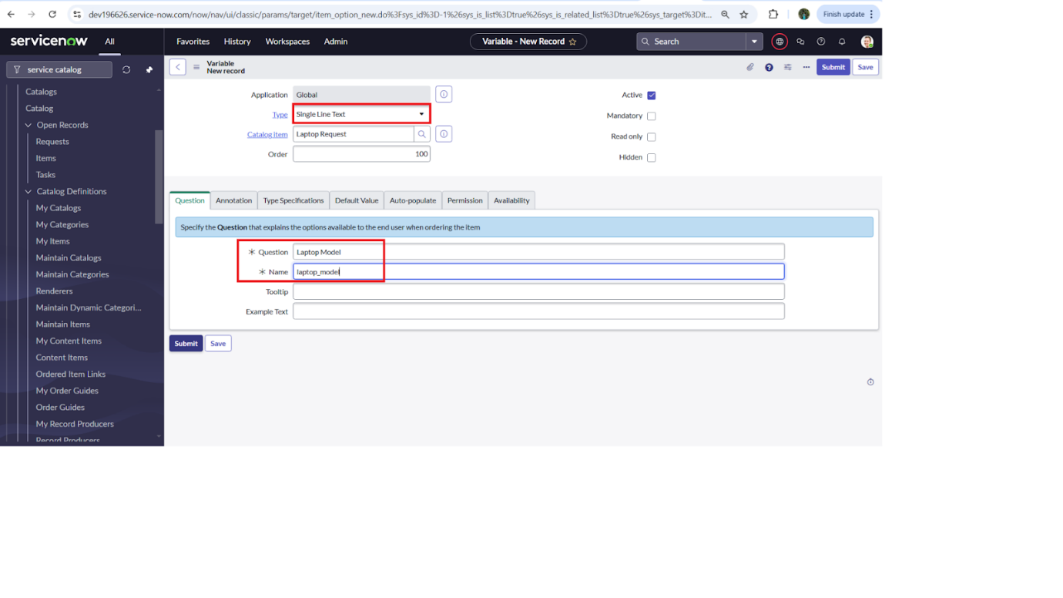

**Step2:**

* After adding above variable which are added to newly created catalog item
* Then save the catalog item form

